Print- List of Directory

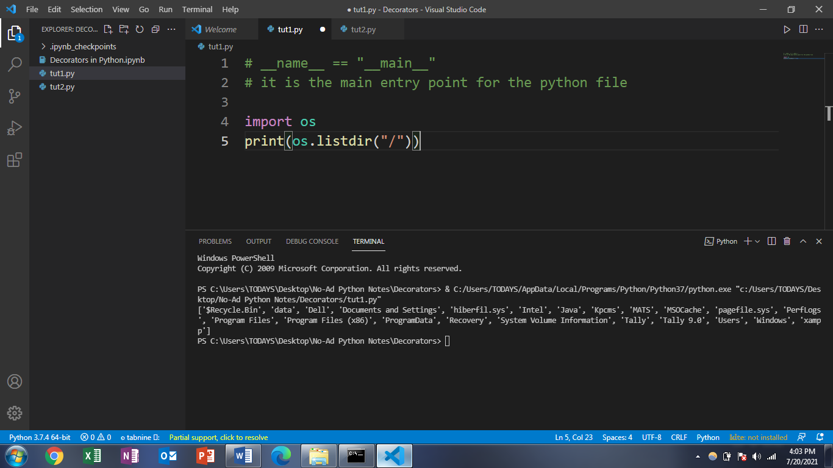





Important Function

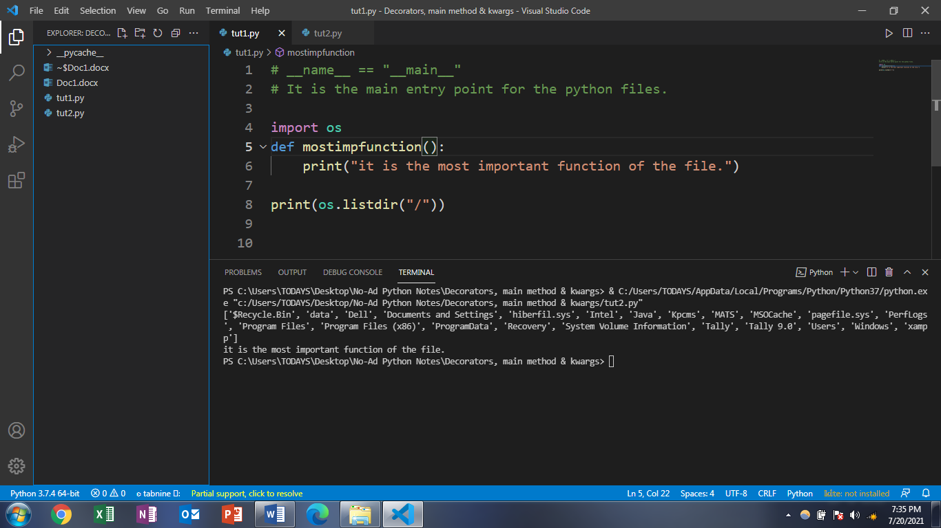



Important function ke saath saath sab functions print ho gye

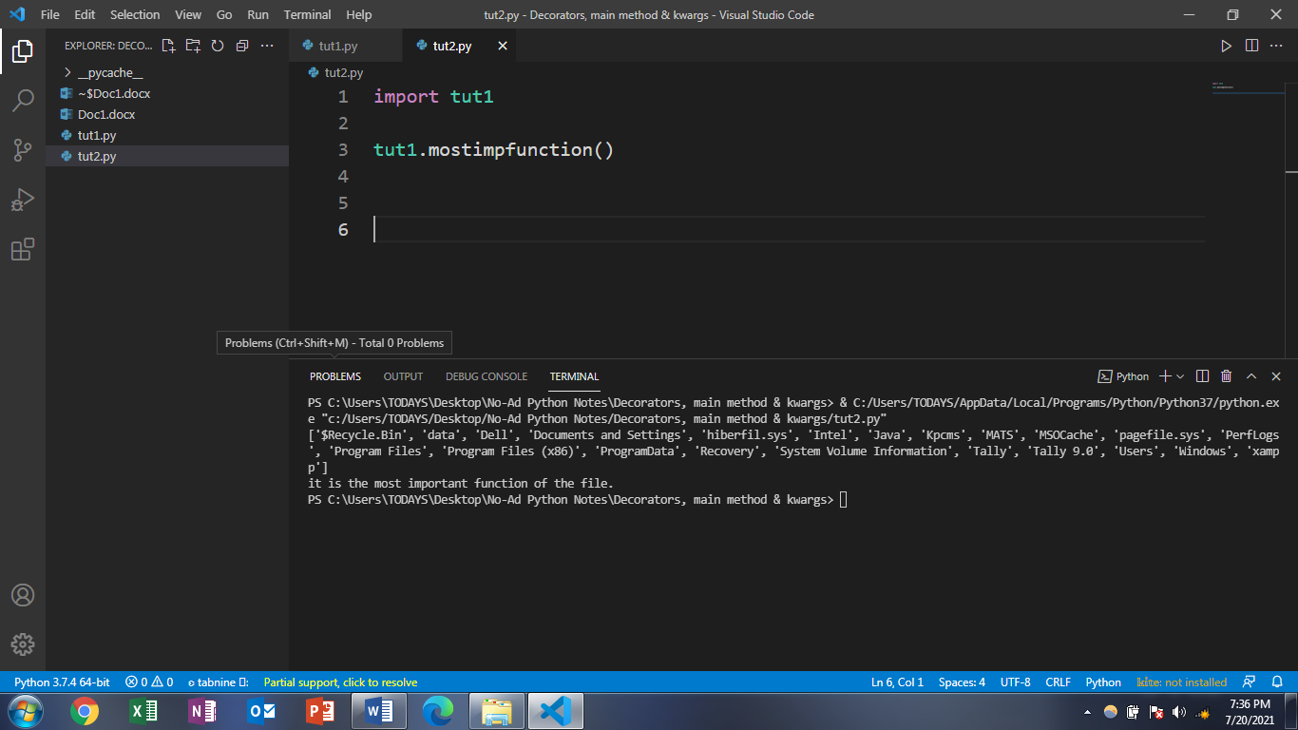



AB Hum Chahte hai ki srf important function hi print ho jaaye.

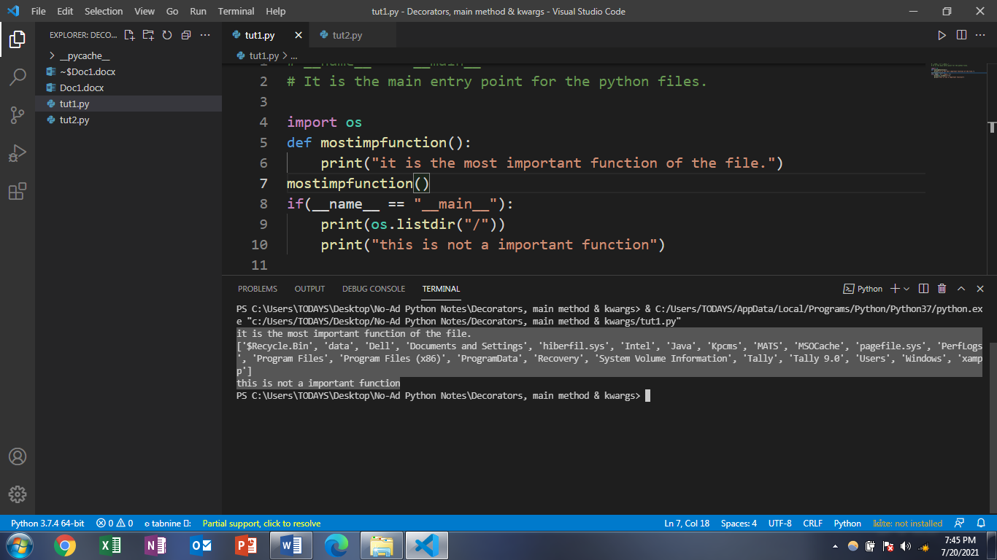



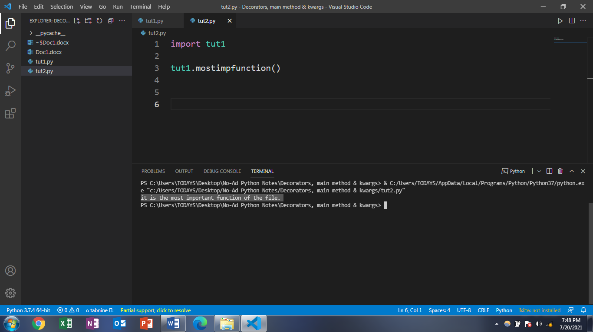



Agar hum wohi file ke __main__:”__name__” ko access kar rhe hai toh print(__main__) humkko name dega.

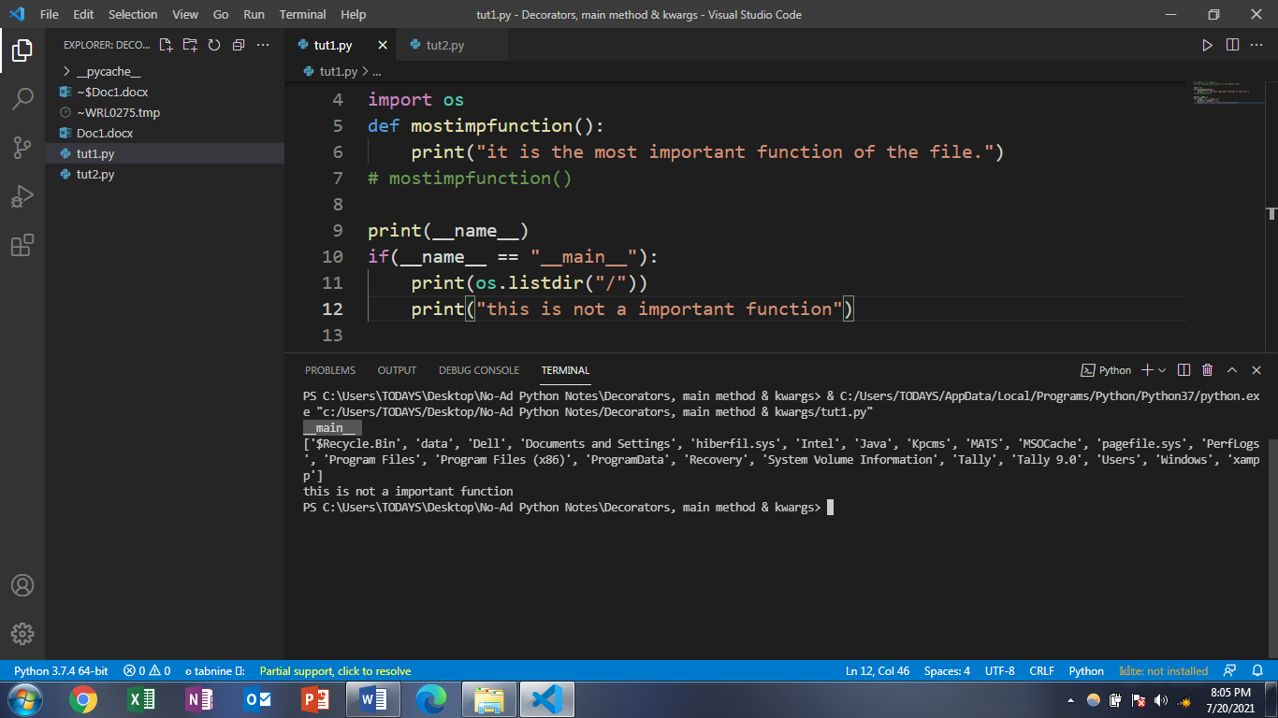

Lekin agar hum dusri file se isko access kar rhe hai toh print(__main__) humko file ka naam dega.

Here name of file is tut1.

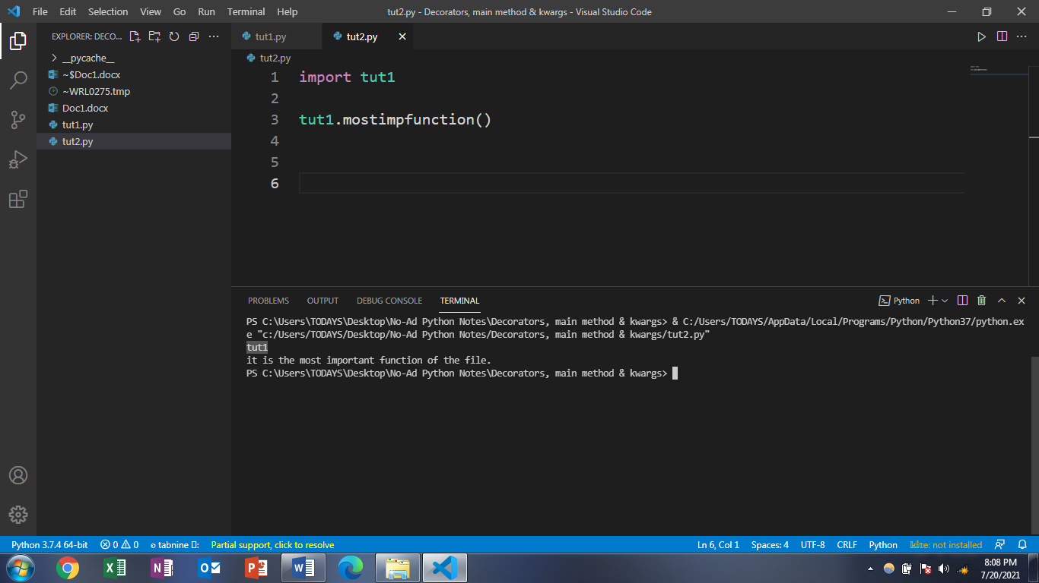

Agar humko esa karna hai ki hum sab ke sub function use kar paaye tut1 ke tut2 mai toh esa karna>>>…

